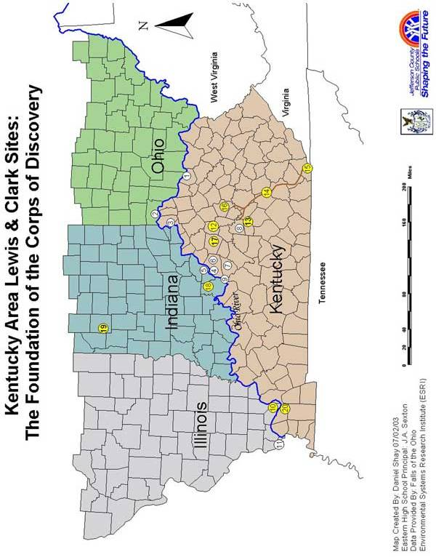
Kentucky Area Lewis & Clark Sites:
The Foundation of the Corps of Discovery

- Maysville, KY—hometown of Private John Colter & a stop for Captain Lewis and his
flotilla on 9/25/1803.
2. Cincinnati, OH—Lewis arrived 9/28/1803 and spent six days purchasing more supplies and meeting with Dr. William Goforth, a researcher of the fossil site across the river in Ky.
3. Big Bone Lick, KY—A famous fossil site, Lewis stayed 5 days and prepared a report for the President on the mammoth & other Ice Age creatures that could still roam out West.
- Louisville—Clark met Lewis on 10/14/1803, and the Lewis & Clark Expedition began. The captains recruited the foundation of the Corps of Discovery & purchased supplies.
- Clarksville, Indiana Territory—William Clark and York had just moved here from Louisville, and the cabin became a temporary headquarters for the Expedition. The keelboat and pirogue left the Falls of the Ohio on 10/26/1803.
- Jefferson County—Several recruits were from this area. Reubin & Joseph Field and Nathaniel Pryor were living here in 1803, Charles Floyd was born here, and George Gibson settled here for a time after the Expedition.
- Bullitt’s Lick—Reubin & Joseph Field, who were a part of the salt-making detail during the winter on the Pacific Ocean, learned the process at brother Ezekial’s salt works here.
- Mercer County—Private Joseph Whitehouse was living here when recruited.
- West Point—Blacksmith & gunsmith John Shields’ hometown.
- Fort Massac, Illinois Territory—the Expedition recruited more men, including Joseph Whitehouse. Fr. Canadian-Shawnee trapper George Drouillard was hired as interpreter.
- Ohio R./Mississippi R. confluence—Clark surveyed the rivers & visited the abandoned Fort Jefferson, established by his brother. Proceeding on the Mississippi, the Expedition was now traveling upstream.

Post-Expedition Sites:
- Frankfort—The first newspaper reports of the Expedition’s return were published here in Oct. 1806. Captain Lewis & the visiting Indian delegation visited here on 11/03/1806.
- Danville—William Clark and York stopped here to visit Clark’s nephews at school on their way to give President Jefferson their final report in Washington, DC.
- Wilderness Road—In late fall of 1806, the returning Captains and their parties traveled the Wilderness Road on their way to Washington, to report to President Jefferson.
- Cumberland Gap—The returning Expedition members left Kentucky by passing through the Cumberland Gap.
- Lexington—In late 1806, trader Pierre Chouteau and the Osage Indian delegation made a stop here. Private George Shannon studied at Transylvania University, then moved back here to marry and become a lawyer and legislator.
- Shelbyville—Clark was visiting here when he learned of Lewis’s death in 1809. Private Alexander Willard married a woman in Shelbyville & they lived here for a few years.
- Harrison County, Indiana Territory—After spending some time as a trapper with Daniel Boone in Missouri, John Shields settled near Corydon. He died there in 1809.
- Waynetown, Indiana Territory—William Bratton settled here after the Expedition and served as school superintendent and justice of the peace.
- Paducah—Expedition co-commander, William Clark, founded this river town in 1827.

