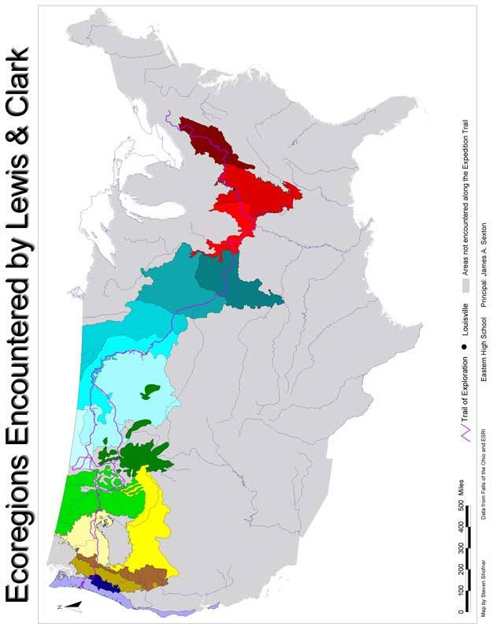
Ecoregions Encountered by Lewis & Clark

Ecoregions Explored, East to West

Mapped for the 2003 Kentucky State Fair, based on the Level III Ecoregions as defined by the United

States EPA: http://www.epa.gov/wed/pages/ecoregions/level_iii.htm
ftp://ftp.epa.gov/wed/ecoregions/na/naeco3.pdf

Ohio, Mississippi & Lower Missouri River Basins
(Eastern Temperate Forests & Southeastern Plains—The Middle West Region)

Western Allegheny Plateau
Interior Plateau
Interior River Lowland

Upper Missouri River Basin
(Temperate Prairie, Semi-Arid Prairie & Great Plains—The Middle West Region)

Central Irregular Plains
Western Corn Belt Plains
Northern Glaciated Plains
Northwestern Great Plains
Northwestern Glaciated Plains
Northern Montana Glaciated Plains

Rocky Mountain Range
(Northwestern Forested Mountains—The West/Mountain Region)

Middle Rockies
Northern Rockies

North American Deserts
(Western Interior Basins & Ranges—The West/Pacific Region)

Snake River Basin/High Desert
Columbia Plateau

Pacific Northwest
(Northwestern Forested Mountains—The West/Pacific Region)

Eastern Cascades Slopes & Foothills
Cascades

Pacific Coast
(Marine West Coast Forest—The West/Pacific Region)

Willamette Valley
Coast Range

