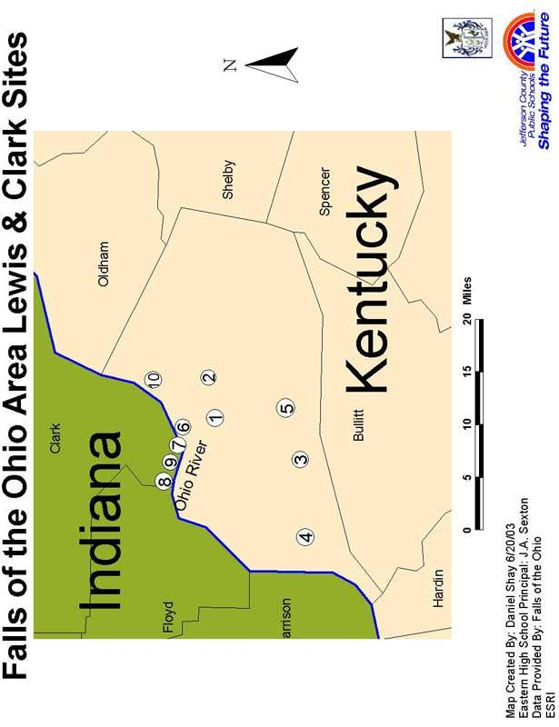
Falls of the Ohio Area Lewis & Clark Sites

- Mulberry Hill—Expedition co-commander William Clark and his slave York lived on this Clark family plantation from 1785-1803. They moved across the river to Point of Rocks just weeks before Lewis arrived. Today, the site that was once Mulberry Hill is George Rogers Clark Park on Poplar Level Road.

- Floyd's Station—Sergeant Charles Floyd, the only Expedition member to die on the journey, was born and raised in this family settlement in present-day St. Matthews. By the time he was recruited, he was living across the river in Indiana Territory.

3/4/5. Fairdale, Valley Station & Okolona - William Clark recruited "the best woodsmen & Hunters...in this part of the Countrey" for the Expedition, and brothers Reubin & Joseph Field were the best of the best. They teamed their skills ranging the forests of the southern part of the Jefferson County where they lived on Pond Creek. Today some of this area is Jefferson County Memorial Forest.

- Louisville—William Clark recruited many of the men for the Expedition in and around Louisville, and the co-commanders met in this growing river city on October 14, 1803. For several days, Lewis & Clark attended to business in Louisville, purchasing supplies and making legal arrangements at the Jefferson County Courthouse.

- Falls of the Ohio—This series of rapids was the greatest navigating challenge along the , Ohio River and contributed to the growth of the cities on cither side of the river. Local pilots were hired to rake the keelboat and pirogue through the falls on October 15, 1803.

- Clarksville, Indiana Territory—William dark's older brother, General George Rogers Clark, founded this town in 1783, on land awarded to veterans of the Revolutionary War Campaign in Illinois Territory. Lewis & Clark prepared for the western journey here.

- Point of Rocks (dark's Point), Indiana Territory—In 1803, George Rogers and William Clark built a cabin here, overlooking the Falls of the Ohio. Called Point of Rocks at that time, it was later known as Clark's Point. The cabin has been recreated at this site.

- Locust Grove—This historic home and farm near the Ohio River was the home of Lucy Croghan and her husband. Lucy, the sister of William Clark, hosted a return dinner for Captains Lewis & Clark on November 8, 1806. The site is the only surviving Lewis & Clark structure west of the Appalachians.

