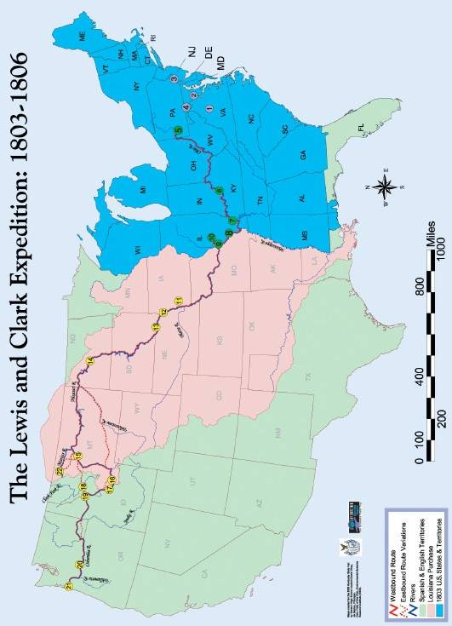

Key Lewis & Clark Expedition Sites: 1803-1806

Preparations
- Monticello
- Washington, DC
- Philadelphia
- Harpers Ferry

Recruitment
- Pittsburgh
- Louisville
- Ft. Massac
- Ft. Kaskaskia
- St. Louis
- Camp Dubois

Exploration
- Council Bluffs
- Floyd’s Grave
- Calumet Bluff
- Ft. Mandan
- Great Falls
- Camp Fortunate
- Shoshone Villages
- Travelers’ Rest
- Lolo Trail
- Columbia Cascades
- Ft. Clatsop
- Camp Disappointment

